BRIEF HISTORY

Castle Hill Bowling Club came into existence as a segment of the Castle Hill RSL sporting complex.
- October 14 1960

29 members meet where the Bowling Club was formed and a committee elected.
- December 1961

Work started on the greens
- November 1962

The property was leased to the Bowling Club.
- July 1963

Full affiliation with the RNSWBA was granted
- August 1963

The first bowls on the new greens were rolled
- May 3 1964

The Club was officially opened
- January 21 1965

The Bowling Club purchased the property from the RSL. The Castle Hill Bowling Club was now its own legal entity.

The Club is now considered the “friendliest club in the Hills” based on community values.

The Club is celebrating its 60th anniversary in 2020 and sponsorship opportunities are now available to allow you to celebrate this significant milestone with us.

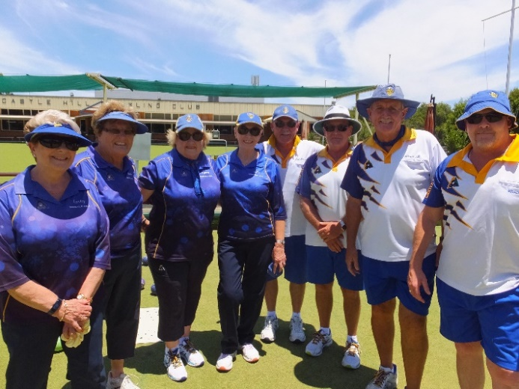

AVAILABLE SPONSORSHIP PACKAGES

To celebrate the 60th Anniversary the Club will be conducting a number of events throughout the year. See over for a calendar of events proposed.

Each of these events will potentially attract bowlers throughout the Hills District to help us celebrate our anniversary and thereby also provide an opportunity for businesses such as yours to market their products and services.

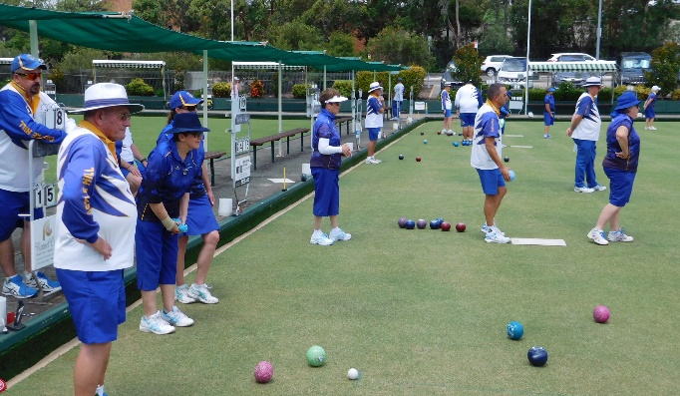

CONTACT DETAILS
Please contact Noel Benson, Director for more information regarding sponsorship opportunities available at Castle Hill Bowling Club.

Phone: 0408 560 007
Email: noel.benson1951@bigpond.com

Club Contact Details
Phone (02) 9634 2192
Email: gm@castlehillbc.com.au
Address 79 Castle Street. Castle Hill NSW 2154
Website: www.castlehillbc.com.au
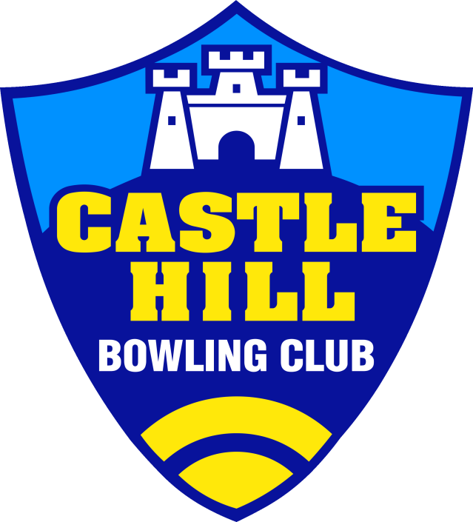

60th
Anniversary
2020

Sponsorship
Packages

